SFP-1000BASE-T Copper SFP Transceiver

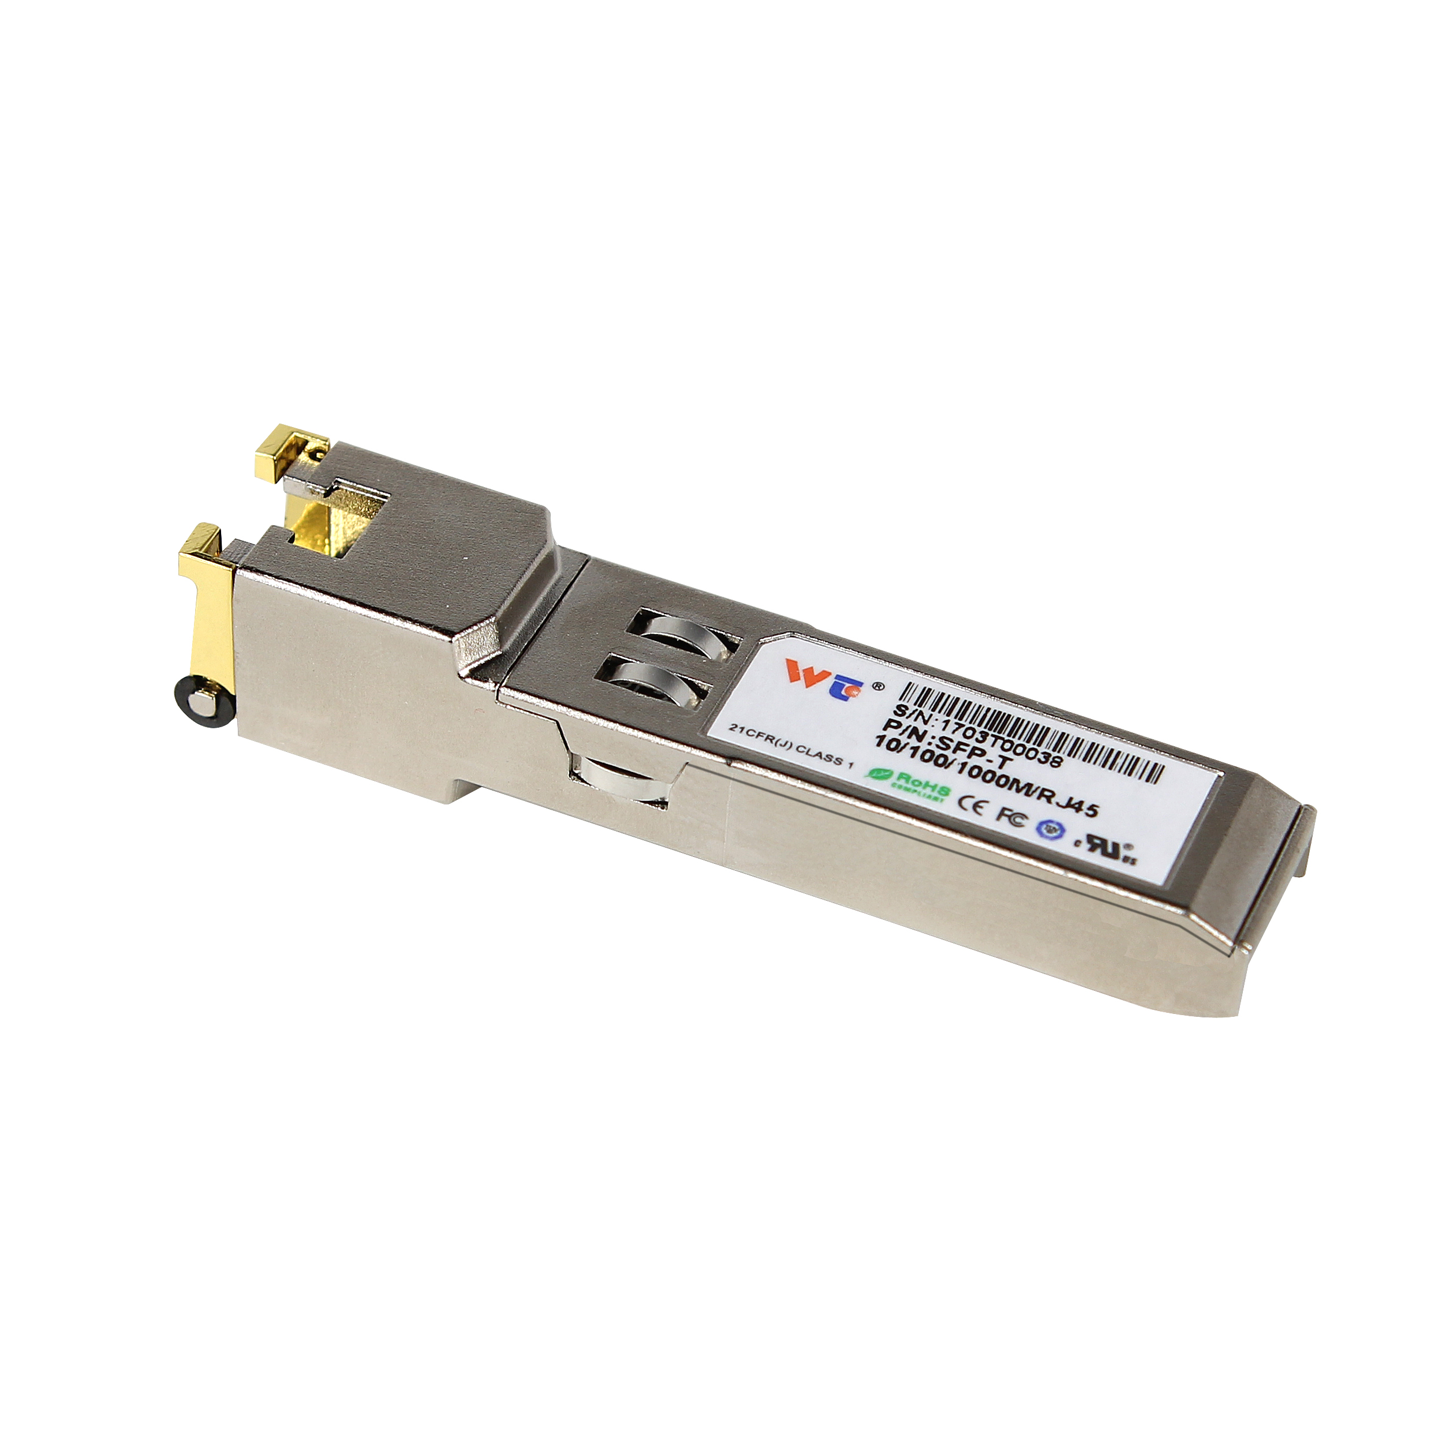
1.PRODUCT FEATURES
- Up to 1.25 Gb/s bi-directional data links
- Hot-pluggable SFP footprint
- Low power dissipation(1.05W typical)
- Compact RJ-45 connector assembly
- Fully metal enclosure, for lower EMI
- RoHS compliant and lead-free
- Single +3.3V power supply
- 1000BASE-T operation in host systems with SERDES interface
- 1.25 Gigabit Ethernet over Cat 5 cable
- Ambient Operating temperature: 0°C to +70°C
2.PRODUCT DESCRIPTION
SFP-1000BASE-T Copper Small Form Pluggable (SFP) transceivers are based on the SFP Multi Source Agreement (MSA) . They are compatible with the Gigabit Ethernet and 1000BASE-T standards as specified in IEEE Std 802.3 . The SFP-1000BASE-T physical layer IC (PHY) can be accessed via I2C, allowing access to all PHY settings and features.
The SFP-1000BASE-T uses the SFP's RX_LOS pin for link indication. If pull up SFP's TX_DISABLE pin, PHY IC be reset.

3. Work Mode
Work Mode | Support
Serdes to 1000base-T | Yes (default)
SGMII to 10/100/1000base-Tx | Yes (realization by configuring PHY IC via I2C, detail in section 10)

4.SFP to Host Connector Pin Out
Pin | Symbol | Name/Description | Ref.
1 | VEET | Transmitter Ground (Common with Receiver Ground) | 1
2 | TFAULT | Transmitter Fault. Not supported.
3 | TDIS | Transmitter Disable. Laser output disabled on high or open. | 2
4 | MOD_DEF(2) | Module Definition 2. Data line for Serial ID. | 3
5 | MOD_DEF(1) | Module Definition 1. Clock line for Serial ID. | 3
6 | MOD_DEF(0) | Module Definition 0. Grounded within the module. | 3
7 | Rate Select | No connection required
8 | LOS | Loss of Signal indication. Logic 0 indicates normal operation.
9 | VEER | Receiver Ground (Common with Transmitter Ground) | 1
10 | VEER | Receiver Ground (Common with Transmitter Ground) | 1
11 | VEER | Receiver Ground (Common with Transmitter Ground) | 1
12 | RD- | Receiver Inverted DATA out. AC Coupled
13 | RD+ | Receiver Non-inverted DATA out. AC Coupled
14 | VEER | Receiver Ground (Common with Transmitter Ground) | 1
15 | VCCR | Receiver Power Supply
16 | VCCT | Transmitter Power Supply
17 | VEET | Transmitter Ground (Common with Receiver Ground) | 1
18 | TD+ | Transmitter Non-Inverted DATA in. AC Coupled.
19 | TD- | Transmitter Inverted DATA in. AC Coupled.
20 | VEET | Transmitter Ground (Common with Receiver Ground) | 1

Notes:
1. Circuit ground is connected to chassis ground
2. PHY disabled on TDIS > 2.0V or open, enabled on TDIS < 0.8V
3. Should be pulled up with 4.7k - 10k Ohms on host board to a voltage between 2.0 V and 3.6 V. MOD_DEF(0) pulls line low to indicate module is plugged in.

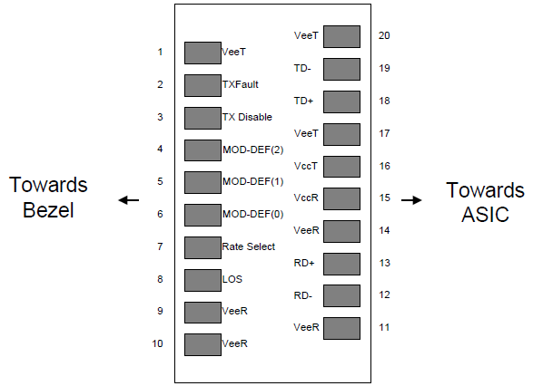

Figure 1. Diagram of host board connector block pin numbers and names

5. +3.3V Volt Electrical Power Interface
The SFP-1000BASE-T has an input voltage range of 3.3 V +/- 5%. The 4V maximum voltage is not allowed for continuous operation.
+3.3 Volt Electrical Power
Interface
Parameter | Symbol | Min | Typ | Max | unit | Notes/Conditions
Supply Current | Is |  | 320 | 375 | mA | 1.2W max power over  full range of voltage  and temperature.  See caution note below
Input Voltage | Vcc | 3.13 | 3.3 | 3.47 | V | Referenced to GND
Maximum Voltage | Vmax |  |  | 4 | V
Surge Current | Isurge |  |  | 30 | mA | Hot plug above steady state  current. See caution note  below

Caution: Power consumption and surge current are higher than the specified values in the SFP MSA

6. Low-Speed Signals
MOD_DEF(1) (SCL) and MOD_DEF(2) (SDA), are open drain CMOS signals (see section VII, "Serial Communication Protocol"). Both MOD_DEF(1) and MOD_DEF(2) must be pulled up to host_Vcc

Low-Speed Signals, Electronic Characteristics
Parameter | Symbol | Min | Max | unit | Notes/Conditions
SFP Output LOW | VOL | 0 | 0.5 | V | 4.7k to 10k pull-up to host_Vcc,  measured at host side of connector
SFP Output HIGH | VOH | host_Vcc -0.5 | host_Vcc + 0.3 | V | 4.7k to 10k pull-up to host_Vcc,  measured at host side of connector
SFP Input LOW | VIL | 0 | 0.8 | V | 4.7k to 10k pull-up to Vcc,  measured at SFP side of connector
SFP Input HIGH | VIH | 2 | Vcc + 0.3 | V | 4.7k to 10k pull-up to Vcc,  measured at SFP side of connector

7.High-Speed Electrical Interface
All high-speed signals are AC-coupled internally.

High-Speed Electrical Interface, Transmission Line-SFP
Parameter | Symbol | Min | Typ | Max | unit | Notes/Conditions
Line Frequency | fL |  | 125 |  | MHz | 5-level encoding, per  IEEE 802.3
Tx Output Impedance | Zout,TX |  | 100 |  | Ohm | Differential, for all  frequencies between  1MHz and 125MHz
Rx Input Impedance | Zin,RX |  | 100 |  | Ohm | Differential, for all  frequencies between  1MHz and 125MHz

High-Speed Electrical Interface, Host-SFP
Parameter | Symbol | Min | Typ | Max | unit | Notes/Conditions
Single ended data input  swing | Vinsing | 250 |  | 1200 | mV | Single ended
Single ended data output  swing | Voutsing | 350 |  | 800 | mV | Single ended
Rise/Fall Time | Tr,Tf |  | 175 |  | psec | 20%-80%
Tx Input Impedance | Zin |  | 50 |  | Ohm | Single ended
Rx Output Impedance | Zout |  | 50 |  | Ohm | Single ended

8.General Specifications
General
Parameter | Symbol | Min | Typ | Max | unit | Notes/Conditions
Data Rate | BR | 10 |  | 1000 | Mb/sec | IEEE 802.3 compatible.  See Notes 2 through 3 below
Cable Length | L |  |  | 100 | m | Category 5 UTP. BER
Notes:
1. Clock tolerance is +/- 50 ppm
2. By default, the SFP-1000BASE-T is a full duplex device in preferred master mode
3. Automatic crossover detection is enabled. External crossover cable is not required

9.Environmental Specifications
Environmental
Specifications
Parameter | Symbol | Min | Typ | Max | unit | Notes/Conditions
Operating Temperature | Top | 0 |  | 70 | °C | Case temperature
Storage Temperature | Tsto | -40 |  | 85 | °C | Ambient temperature

10. Serial Communication Protocol
All WINTOP SFPs support the 2-wire serial communication protocol outlined in the SFP MSA. These SFPs use an MCU, can be accessed with address of A0h.
Serial Bus Timing, Requirements

Parameter | Symbol | Min | Typ | Max | unit | Notes/Conditions
I 2C Clock Rate |  | 0 |  | 200,000 | Hz
The SFP-1000BASE-T physical layer IC can also be accessed via the 2-wire serial bus at address ACh. For details interfacing with the PHY IC, see Marvell data sheet titled "Alaska Ultra 88E1111 Integrated Gigabit Ethernet Transceiver" (Marvell document number MV-S100649-00).

11. Outline Dimensions (mm)

