WTPD-Exx9-1B-D
SFP, CWDM, 155Mbps , 120K m，LC，DDM

1. Feature:
- SFP package with LC connector
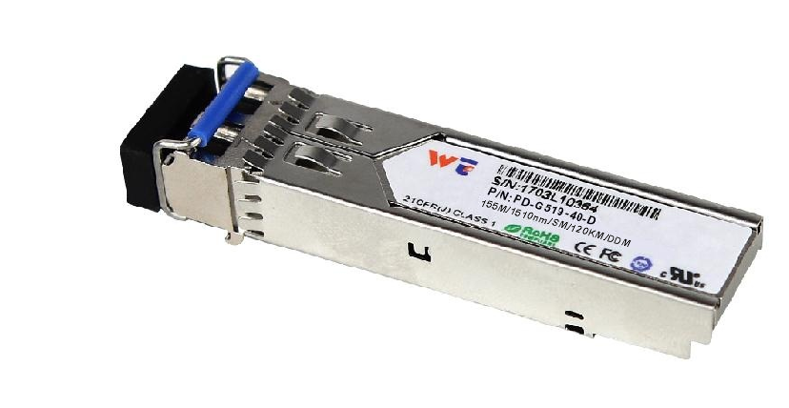
- CWDM wavelength laser and PIN photo detector
- Up to 120Km transmission on SMF
- +3.3V single power supply
- LVPECL compatible data input/output interface
- Low EMI and excellent ESD protection
- laser safety standard IEC-60825 compliant
- Compatible with RoHS
- Digital Diagnostic SFF-8472 compliant
- Signal Ground Isolated to Case

2. Application:
- Optical Supervisory Channel for SONET OC-3 and Fast Ethernet
3. Absolute Maximum Ratings:
Parameter | Symbol | Minimum | Maximum | Units
Storage Temperature | Tst | -40 | +85 | °C
Supply Voltage | Vcc | 0 | +3.6 | V
Operating Relative Humidity | RH | 5 | 95 | %
4. Operation Environment:
Parameter | Symbol | Min | Typical | Max | Units
Supply Voltage | Vcc | 3.15 | 3.3 | 3.45 | V
Operating Case Temperature | Tc | 0 |  | +70
Power Dissipation |  |  |  | 1 | W
Data Rate |  |  | 155 |  | Mbps
5. Optical Characteristics:
(Ambient Operating Temperature 0°C to +70°C, Vcc =3.3 V)
Parameter | Symbol | Min. | Typ. | Max. | Units
Transmitter Section
Center Wavelength | λo | λc-7 | λc+n*20 | λc+7 | nm
Spectral Width(RMS) | Δλ | - | - | 0 | nm
Average Output Power | Po | 0 | - | 5 | dBm
Extinction Ratio | Er | 8 | - |  | dB
Rise/Fall Time(20%~80%) | Tr/Tf |  |  | 0.8 | ns
Total jitter | Tj |  |  | 0.07 | UI
Optical Eye Diagram | IEEE 802.3z and ANSI Fibre Channel Compatible
Receiver Section
Center Wavelength | λo | 1260 |  | 1620 | nm
Receiver Sensitivity | Rsen |  |  | -34 | dBm
Receiver Overload | Rov | -3 |  |  | dBm
Return Loss |  | 12 |  |  | dB
LOS Assert | LOS_{A} | -45 |  |  | dBm
LOS Dessert | LOS_{D} |  |  | -35 | dBm
LOS Hysteresis |  | 0.5 |  | 5
6. Electrical Characteristics:
(Ambient Operating Temperature 0°C to +70°C, Vcc =3.3 V)
Parameter |  | Symbol | Min. | Typ. | Max. | unit
Transmitter Section
Input Differential Impendence |  | Zin | 90 | 100 | 110 | Ohm
Data Input Swing Differential |  | Vin | 500 |  | 2400 | mV
TX Disable | Disable |  | 2.0 |  | Vcc | V
TX Disable | Enable |  | 0 |  | 0.8 | V
TX Fault | Assert |  | 2.0 |  | Vcc | V
TX Fault | Deassert |  | 0 |  | 0.8 | V
Receiver Section
Output differential impendence |  | Zout |  | 100 |  | Ohm
Data Input Swing Differential |  | Vout | 370 |  | 2000 | mV
Rx_LOS | Assert |  | 2.0 |  | Vcc | V
Rx_LOS | Deassert |  | 0 |  | 0.8 | V

7. EEPROM INFORMATION（A0）:

Addr | Field Size  (Bytes) | Name of Field | HEX | Description
0 | 1 | Identifier | 03 | SFP
1 | 1 | Ext. Identifier | 04 | MOD4
2 | 1 | Connector | 07 | LC
3-10 | 8 | Transceiver | 00 00 00 02 12 00 0D 01 | Transmitter Code
11 | 1 | Encoding | 02 | 4B5B
12 | 1 | BR, nominal | 02 | 155M bps
13 | 1 | Reserved | 00
14 | 1 | Length (9um)-km | 78 | 120km
15 | 1 | Length (9um) | FF
16 | 1 | Length (50um) | 00
17 | 1 | Length (62.5um) | 00
18 | 1 | Length (copper) | 00
19 | 1 | Reserved | 00
20-35 | 16 | Vendor name | 57 49 4E 54 4F 50 20 20  20 20 20 20 20 20 20 20 | WINTOP
36 | 1 | Reserved | 00
37-39 | 3 | Vendor OUI | 00 00 00
40-55 | 16 | Vendor PN | xx xx xx xx xx xx xx xx  xx xx xx xx xx xx xx xx | ASC II
56-59 | 4 | Vendor rev | 31 2E 30 20 | V1.0
60-61 | 2 | Wavelength | 06 0E | 1550nm
62 | 1 | Reserved | 00
63 | 1 | CC BASE | XX | Check sum of byte 0~62
64-65 | 2 | Options | 00 1A | LOS, TX_DISABLE, TX_FAULT
66 | 1 | BR, max | 32 | 50%
67 | 1 | BR, min | 32 | 50%
68-83 | 16 | Vendor SN | 00 00 00 00 00 00 00 00  00 00 00 00 00 00 00 00 | Unspecified
84-91 | 8 | Vendor date code | XX XX XX 20 | Year, Month, Day
92-94 | 3 | Reserved | 00
95 | 1 | CC_EXT | XX | Check sum of byte 64~94
96-255 | 160 | Vendor specific

8. Diagnostics:
Parameter | Range | Accuracy | Unit | Calibration
Temperature | 0 ~ 70 | ±3 | ºC | Internal
Voltage | 0 ~ VCC | 0.1 | V | Internal
Bias Current | 10 ~ 80 | ±2 | mA | Internal
Tx Power | 0 ~ 5 | ±2 | dBm | Internal
Rx Power | -36~-3 | ±3 | dBm | Internal

9. Pin Description:
Pins | Name | Discription | NOTE
1 | VeeT | Transmitter Ground
2 | Tx Fault | Transmitter Fault Indication | 1
3 | Tx Disable | Transmitter Disable | 2
4 | MOD DEF2 | Module Definition 2 | 3
5 | MOD DEF1 | Module Definition 1 | 3
6 | MOD DEF0 | Module Definition 0 | 3
7 | Rate Select | Not Connected
8 | LOS | Loss of Signal | 4
9 | VeeR | Receiver Ground
10 | VeeR | Receiver Ground
11 | VeeR | Receiver Ground
12 | RD- | Inv. Received Data Output | 5
13 | RD+ | IReceived Data Output | 5
14 | VeeR | Receiver Ground
15 | VccR | Receiver Power
16 | VccT | Transmitter Power
17 | VeeT | Transmitter Ground
18 | TD+ | Transmit Data Input | 6
19 | TD- | Inv. Transmit Data Input | 6
20 | VeeT | Transmitter Ground
Notes:
1. TX Fault is an open collector output, which should be pulled up with a 4.7k~10kΩ resistor on the host board to a voltage between 2.0V and Vcc+0.3V. Logic 0 indicates normal operation; logic 1 indicates a laser fault of some kind. In the low state, the output will be pulled to less than 0.8V.
2. TX Disable is an input that is used to shut down the transmitter optical output. It is pulled up within the module with a 4.7k~10kΩ resistor. Its states are:
Low (0~0.8V): Transmitter on
(>0.8V, <2.0V): Undefined
High (2.0~3.3V): Transmitter Disabled
Open: Transmitter Disabled
3. MOD-DEF 0,1,2 are the module definition pins. They should be pulled up with a 4.7k~10kΩ resistor on
the host board. The pull-up voltage shall be VccT or VccR.
MOD-DEF 0 is grounded by the module to indicate that the module is present
MOD-DEF 1 is the clock line of two wire serial interface for serial ID
MOD-DEF 2 is the data line of two wire serial interface for serial ID
4. LOS is an open collector output, which should be pulled up with a 4.7k~10kΩ resistor on the host board to a voltage between 2.0V and Vcc+0.3V. Logic 0 indicates normal operation; logic 1 indicates loss of signal. In the low state, the output will be pulled to less than 0.8V.

5. These are the differential receiver output. They are internally AC-coupled 100Ω differential lines which should be terminated with 100Ω (differential) at the user SERDES.
6. These are the differential transmitter inputs. They are AC-coupled, differential lines with 100Ω differential termination inside the module.
10. Recommended Application Circuit:
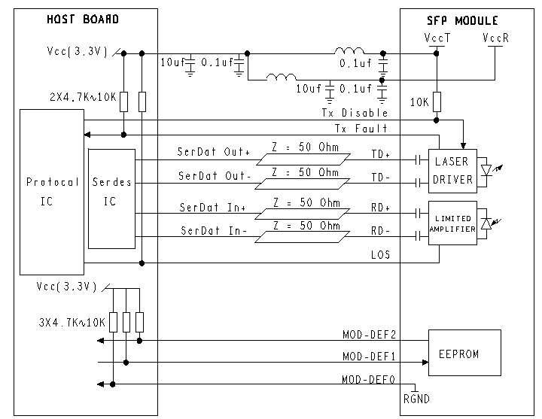
11. Outline Dimensions (mm):
